Lesson 1: Whistler’s Quest for Beauty

“He is determined to make beauty out of the every day. He saw what was before him but he then turns it into artistry.”
- David Park Curry, Senior Curator, Baltimore Museum of Art

Table of Contents
[each of the following should be links to the activity within this lesson]

Introduction
Guiding Questions
Learning Objectives
Background for Teachers
Preparing to Teach This Lesson
Suggested Activities

Activity 1. Introduce, View, and Discuss the Film, James McNeill Whistler & The Case for Beauty
Lesson 1.1 Worksheet Reviewing Whistler Film
Lesson 1.2 Worksheet Reviewing Whistler Film Answers

Activity 2. Read, Think, Write (Whistler’s life)
Lesson 1.3 Biography The Artist- James McNeill Whistler
Lesson 1.4 Assignment Sheet for Whistler’s Life and Time Essay
Lesson 1.5 Artist and Marketplace Essay

Activity 3. Look and Think (Whistler’s The Balcony)
Lesson 1.6 Study Guide Look and Think about Whistler’s The Balcony
Lesson 1.7 Study Guide Look and Think about Whistler’s The Balcony Answer Sheet

Activity 4 Studio: Gesture Studies

Art Image: Study for The Three Girls

Art Image: Study of Crouching Woman

Lesson 1.8 Assignment for Studio: Gesture Studies

Lesson 1.8 Extension: Gesture Studies

Activity 5 Studio Assessment Activity: Design a Whistler Exhibition
Lesson 1.9 Assignment Sheet for Designing a Whistler Exhibition
Lesson 1.9 Extension: Design a Whistler Exhibition
Lesson 1.10 Assessment Rubric for Designing a Whistler Exhibition

Extending the Lesson
Lesson 1.8 Extension: Sketching Gesture Studies
Lesson 1.9 Extension: Design a Whistler Exhibition

Handouts for Lesson 1
The Basics
Standards Alignment

Introduction
James McNeill Whistler, an expatriate American artist, strayed from the accepted realism of 19th-Century art when he began to create beautiful art with neither story nor moral but was just “art for art’s sake.” This radical concept would lead to the abstractions of the 20th-Century. But first Whistler had to promote and defend his vision to critics and patrons.

In this lesson students view the PBS film James McNeill Whistler & The Case for Beauty. After reading a short biography of Whistler and studying timelines of his life, they write an essay explaining how world events influenced Whistler. They view caricatures of Whistler and read about the public persona he created to market his art. Students identify Japanese influences in Whistler’s painting Variations in Flesh Colour and Green: The Balcony, view his preliminary figure studies, and create their own quick gesture drawings. To summarize their learning, they design a display of thumbnail images of Whistler’s art.

Guiding Questions
Why did Whistler develop an eccentric public personality?
How did world events influence Whistler and his art?

Learning Objectives
At the end of this lesson students will be able to:
- Describe Whistler’s public and private personality.
- Write a short essay explaining how several world events affected Whistler’s life and art.
- Describe Whistler’s painting, The Balcony.
- Identify Japanese influences within The Balcony.
- Discuss Whistler’s study sketches.
- Sketch figures in poses similar to those in The Balcony and Whistler’s studies.
- Describe how Whistler exhibited and marketed his art.
- Design an exhibit of Whistler’s art. Explain why they would arrange and exhibit the art in this way.

Background Information for the Teacher
Although born in the United States, James McNeill Whistler (1834-1903) lived most of his life in Europe. He first studied art in St. Petersburg, was expelled from West Point, led a Bohemian life in Paris, and settled near the Thames River in London. He drew and etched the rough and tumble world of the Thames docklands. Whistler was a talented draughtsman who sketched incessantly. During his early career he followed Courbet’s precepts of realism, painting what he saw. But, he took to heart Baudelaire’s suggestion that artists find beauty in modern urban surroundings.

When Japan opened to Western trade, Whistler and other artists became obsessed with Japanese prints and ceramics. When Whistler raised the horizon line and limited color as in Japanese prints, his urban landscapes became more abstract. When his mother fled America’s Civil War and joined him in London, he painted his iconic portrait of her.

Whistler’s increasingly abstract paintings seemed strange to London art critics. However, Whistler discovered that he could defend and call attention to his art (and sell it) by writing witty rebuttal letters to newspapers. He developed an outrageous outward persona to market his art. Learn more about Whistler in the essay Whistler’s Place in Nineteenth Century Art <Whistler’s Place in Nineteenth Century Art [Whistler Docent Bio in Dropbox]>

Preparing to Teach This Lesson
Review the lesson plan and the websites used throughout. Locate and bookmark suggested materials and websites. Download and print out documents you will use. Duplicate copies as necessary for student viewing.
Students can access materials at <http://www.whistlerthemovie.com>.
Reproducible Handouts for Whistler Lesson 1:
[Link to each of the following within this lesson]
Lesson 1.1 Worksheet Reviewing Whistler Film
Lesson 1.2 Worksheet Reviewing Whistler Film Answers
Lesson 1.3 Biography The Artist - James McNeill Whistler
Lesson 1.4 Assignment Sheet for Whistler Life and Time Essay
Lesson 1.5 The Artist and Marketplace Essay
Lesson 1.6 Study Guide Look and Think about Whistler’s The Balcony
Lesson 1.7 Study Guide Look and Think about Whistler’s The Balcony Answer Sheet
Lesson 1.8 Assignment For Studio: Gesture Studies
Lesson 1.8 Extension: Sketching Gesture Studies
Lesson 1.9 Assignment Sheet for Designing a Whistler Exhibition
Lesson 1.9 Extension: Design a Whistler Exhibition
Lesson 1.10 Assessment Rubric for Designing a Whistler Exhibition

Suggested Activities
[each of the following should be links to the activity within this lesson]
Activity 1. Introduce, View, and Discuss the Film, James McNeill Whistler & The Case for Beauty

Activity 2. Read, Think, Write (Whistler’s Life)

Activity 3. Look and Think (Whistler’s The Balcony)

Activity 4. Studio: Gesture Studies

Activity 5. Studio Assessment: Design a Whistler Exhibit

Activity 1. Introduce, View, and Discuss the Film, James McNeill Whistler & The Case for Beauty

Before students view the video, James McNeill Whistler & The Case for Beauty, tell them to notice Whistler’s public personality as well as his serious private side. Also, they should note how his art changed over his lifetime.

After viewing the film, students may write answers to the questions on the Lesson 1.1 Worksheet Reviewing Whistler Film [link to it]
Have students discuss their answers with the class. Encourage them to add information to their worksheets that they learn in these discussions.
Compile a class list of student responses to the worksheet questions. You might wish to use the Lesson 1.2 Worksheet Reviewing Whistler Film Answers
Students’ answers should be similar to the following examples:

1. Write three words or phrases to describe Whistler’s public persona or personality.
Confident,
belligerent,
argumentative,
thin-skinned, prickly,
often charming,
witty, sarcastic,
at times fun to be with,
unpredictable
(or similar terms and phrases)

2. Write three words or phrases describing Whistler’s appearance. Black curly hair with a white lock that he sometimes tied with a ribbon,
wore a monocle,
carried a wand,
careful or natty dresser, a dandy
color coordinated how he dressed with his art exhibition – once even wearing yellow socks
(or similar terms and phrases)

3. Write three words that describe some of his work habits and art-making.
Not serious – early in his career
Serious, hard working – later in his career
Experimental
Painted his Nocturnes from memory
Sketched incessantly
(or similar terms and phrases)

4. At the beginning of his art career, what was Whistler trying to achieve or show in his art?
At the beginning of his career Whistler tried to show realistic looking scenes of everyday life.

5. Towards the end of Whistler’s art career, what was he trying to achieve or show in his art?
His goal was to create beautiful art, “art for art’s sake” that did not tell a story or have a moral.
Activity 2. Read, Think, Write (Whistler’s Life)

1. Whistler’s Life and Times
Have students view Comparative Timeline <http://www.odysseymedia.org/productions/whistler/about-the-artist/timeline/>
Call attention to some of the significant events in Whistler’s life.

Discuss how events in Europe, United States, and Japan influenced Whistler.

Russian Czar Nicholas I invited Whistler’s father to design the St. Petersburg to Moscow railroad in 1842. Therefore, as a young boy Whistler studied art and learned to speak French in the Russian court.

When Whistler’s mother fled the Civil War in the United States, she came to live with him in London. He painted her portrait during this time.

London as the center of world trade and commerce in the 19^{th-} Century provided a market for Whistler’s art. Its growing middle class was prosperous enough to purchase Whistler’s paintings and prints.

When Japan began trading with western nations in the 1850s, Whistler and other American and European artists were influenced by Asian art, particularly Japanese prints.
Have students read “The Artist – James McNeill Whistler”, [link to Lesson 1.3 Biography The Artist James McNeill Whistler] a 1-page reproducible biography of Whistler. Using this handout and the online timelines about his life and world events, have students write a short essay explaining how events in Europe, the United States, and Japan influenced Whistler’s life and art. See the reproducible Assignment Sheet for Whistler Life and Time Essay [add Link to Lesson 1.4 Assignment Sheet for Whistler Life and Time Essay ].

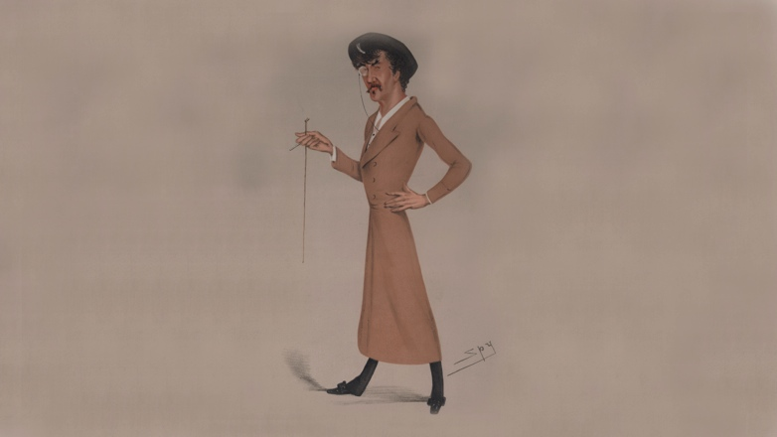

2. Whistler and the Marketplace
Have students read “The Artist and Marketplace,” < Lesson 1.5 The Artist and Marketplace Essay> a 1-page reproducible essay about Whistler’s self-promotion.

Ask: What was Whistler’s point in the opening quote of the “The Artist and Marketplace” essay? Whistler was ridiculing the critic who had written a bad review of his art. He was trying to show that the critic did not know what he was talking about and did not understand art.

Ask: How did Whistler call attention to himself and his art. He dressed and acted eccentrically, wrote letters to newspapers in response to any criticism of his art, and invited critics and patrons to see his art.

Ask: Why did Whistler seek public attention to himself. He wanted the public to notice him and buy his art.

Encourage students to think of public personalities who act and dress to call attention to themselves. Students may suggest movie stars and musicians.

3. Caricatures of Whistler
Show students Whistler caricature in Vanity Fair, 1878, Courtesy of the University of Virginia <http//www.odysseymedia.org/art-life/sellingthevision/1-Whistler-spy-vanityfair-1878/>

Ask students to describe Whistler in this caricature.
They should notice his dark curly hair with one white lock, his monocle, cigarette, wand, hat, long coat, bows on shoes, mustache, bushy eyebrows, cocked head, long fingers on waist, and stare at the viewer. He is dressed to go out.

Ask: What does this pose suggest about Whistler’s personality. Students should note that he seems sure of himself. His cocked head, hand on waist, and glare seem to challenge the viewer.

Explain that this is Whistler’s public appearance and persona.

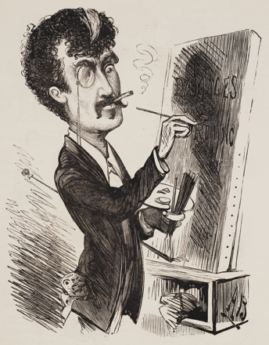
Show students a Whistler Caricature in Entr'acte Almanack, 1879 [Link to 3_LOC Whistler Almanack 1879.tif].

Ask: What does this caricature tell us about Whistler. Encourage students to look for clues in the drawing. It shows Whistler painting intently. He has written, “Damages one farthing” on the canvas referring to his libel suit against John Ruskin (that is covered in Lesson 4, Aesthetics). Perhaps the mask hanging out of his jacket pocket suggests his public mask or face.

Activity 3. Look and Think (Whistler’s The Balcony)

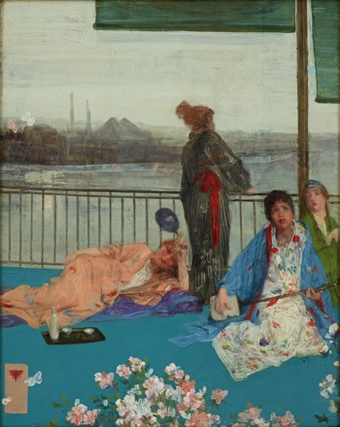
[link to 7_Freer The Balcony.tif]
James McNeill Whistler, "Variations in Flesh Colour and Green: The Balcony," c.1864–70, Oil on panel, 61.4 x 48.8 cm, Freer Gallery of Art, Smithsonian Institution, Washington, Gift of Charles Lang Freer

Have students view a large image of Whistler’s The Balcony for a few minutes before they write their answers on the Study Guide Look and Think about Whistler’s The Balcony [link to Lesson 1.6 Study Guide Look and Think about Whistler’s The Balcony ]. Use the study guide questions and students’ answers as a framework for a class discussion about the art. See Study Guide Look and Think about Whistler, The Balcony Answer sheet [link to Lesson 1.7 Study Guide Look and Think about Whistler The Balcony Answer Sheet].

Ask students to identify the objects in question 1 on a large image of The Balcony. Add information to the class discussion as students point out the objects.
A Balcony railing Model leans against it as it cuts across middle of picture plane
This was the view from Whistler’s window.

B Thames River Behind railing
The Thames River bisects London. It is and was a major transportation artery and location for industry. During the 19^{th-} Century the Thames was heavily polluted as residents dumped their sewage into the river.

C Cherry blossoms lower edge
Thoughout Japanese history, cherry blossoms have been cherished as a symbol of life, death, and rebirth.
D Industrial city landscape above river in background
Whistler found beauty in this cityscape of Battersea, one of London’s most industrial and dirty areas. Note how blurred this part of the painting is. Although structures are recognizeable, over time Whistler’s landscapes were increasingly abstract.

E Horizon line just above the cityscape in the background.
As in Japanese compositions, the horizon line is higher than that in most western art.

F Foggy London sky and atmosphere above and around the city and smokestacks
Point out the smoke on the left. This fog and polluted air from London’s coal furnaces blurs the landscape.

H Japanese fan held by reclining woman

G Kimono (long, wide-sleeved Japanese robe worn with an obi tied around the waist.) All these women are in loose robes, but the one standing wears a kimono with an obi.

I Shamisen (a Japanese three-stringed music instrument) Woman in white print and blue robe holds the shamisen.

J Sake set (for serving a Japanese alcoholic beverage made from rice) near the reclining woman’s knees

K Butterflies lower left corner and near the middle edge on the left. Butterflies were Whistler’s mark. He included them as his signature on art and correspondence.

L Artist’s chop mark, similar to a Japanese seal lower left corner.
Chinese and Japanese artists mark their art with their personal signature stamp. Even today people in China stamp their bank checks with individual chop marks.

2. From his title, Variations in Flesh Colour and Green: The Balcony, we know Whistler was experimenting with color. Locate different flesh tones in this painting. Where has Whistler repeated various shades of pink and flesh tones? Faces, arms, hands, flowers, chop mark background.
Most of this painting is in cool blues with spots of red and pink repeated through out. Repetiton of colors unifies the painting.

3. Which main lines tie the composition to the edge of the picture frame? Vertical pole on left and the horizontal balcony line.
The figures are not centered but arranged along these main lines. The figures’ bodies extend past the edges of the painting, to suggest an informal composition, like a snapshot of a household scene. This type of informal composition was typical of Japanese prints.

4. Describe the brushstrokes on the kimonos and background landscape. The brushstrokes vary but many are visible, long ribbon-like strokes inspired by the drapery of Greek sculptures and some seem sketchy.

5. What part of this painting is most abstract, with the fewest recognizable details? The cityscape in the background hazy fog.

Interpret
6. What happened in Japan that enabled Whistler and other European artists to see Japanese art? Japan opened up to trade with western nations.
As Japanese prints and porcelain appeared in European cities, artists were fascinated by the Asian objects and art compositions.

Extension
Students may watch a “shamisen”, the Japanese three-stringed instrument in Whistler’s The Balcony, being played in a YouTube video. <http://www.youtube.com/watch?v=qWJrMA3zJ5o>

Activity 4. Studio: Gesture Studies

Look Show students Whistler’s studies,
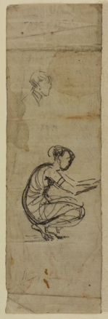
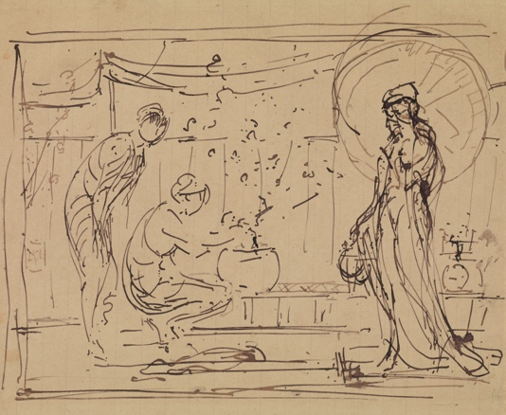
Study for “The Three Girls,” c.1869-1872, Black ink on buff grey-lined wove paper, 18.3 x 21.7 cm, Hunterian Art Gallery, University of Glasgow, Birnie Philip Bequest 1958 [Link to drawing 3A Study of The Three Girls 1869-72 GLAHA_46029.jpg]
and
Studies of a man’s head and a crouching woman, c. 1869-1872, drawing, Pencil on off-white laid paper, 17.7 x 5.4 cm, Hunterian Art Gallery, University of Glasgow [link to drawing 3B Woman Crouching GLAHA 46028.jpg].

Explain that these are quick sketches to capture the figures’ gestures or action. In the Crouching Woman the lines are sketchy, scribbles. No attempt is made to make them perfect, rather the artist seeks to quickly capture a movement. Notice how few lines Whistler used in the two left figures of the Three Girls study. Invite students to speculate on how long it took Whistler to sketch each of these. Whistler sketched studies like this as he experimented with poses and compositions for his large paintings.

Lesson 1.8 Assignment for Studio: Gesture Studies: Have students take turns posing in positions similar to those of the Whistler studies and The Balcony. Limit each pose to 1 to 2 minutes. Encourage students to experiment with line as they draw each pose. Try making scribbles without lifting the pen. In others use short sketchy lines. Invite athletes and dancers to pose in sport or dance positions. Students may draw with pencils or markers on drawing paper. They should select one of their sketches to display in a class exhibit. They may save the other sketches in portfolios.

Lesson 1.8 Extension – Gesture Studies: Students may add color to their figure sketches with markers or paint.

Activity 5. Studio Assessment Activity: Design a Whistler Exhibition
Have students develop a visual plan for displaying some of Whistler’s art. They should suggest the size and color of the exhibition space, the needs of the viewer, and the layout of the exhibition.
Lesson 1.9 Studio Assignment. Students may use the Assignment Sheet for Designing a Whistler Exhibition [link to Lesson 1.9 Assignment Sheet for Designing a Whistler Exhibition] to create their plan. It contains a sheet of thumbnail images of Whistler’s art. Either print this sheet and have students cut and paste the images to show how they would arrange this exhibit or they may use a computer to plan their exhibit. Students may include other examples of Whistler’s art from the film website. An assessment rubric is included for this assignment. [link to Lesson 1.10 Assessment Rubric for Whistler Art Exhibition Design]
Lesson 1.9 Extension – Design a Whistler Exhibition. Students may create box dioramas of their exhibition. There is one pictured in the film James McNeill Whistler & The Case for Beauty.

The Basics
Grade levels – 6-8 or 9-12
Subject areas
Art and Culture: Visual Arts, Art History
Literature and Language Arts: Common Core, American Biography
Time required 3 or 4 periods

Standards Alignment National Core Arts Standards: National Visual Arts Standards <http://nationalartsstandards.org>
Grade 6
VA:Pr5.1.6
Individually or collaboratively, develop a visual plan for displaying works of art, analyzing exhibit space, the needs of the viewer, and the layout of the exhibit.
Grade Hs proficient
VA:Pr5.1.HSI
Analyze and evaluate the reasons and ways an exhibition is presented.
Grade Hs accomplished
VA:Pr6.1.HSII
Make, explain, and justify connections between artists or artwork and social, cultural, and political history.
Grade Hs advanced
VA:Pr.4.1.HSIII
Critique, justify, and present choices in the process of analyzing, selecting, curating, and presenting artwork for a specific exhibit or event.
Grade 8
VA:Re7.1.8
Explain how a person’s aesthetic choices are influenced by culture and environment and impact the visual image that one conveys to others.
Grade 7
VA:Re8.1.7
Interpret art by analyzing art-making approaches, the characteristics of form and structure, relevant contextual information, subject matter, and use of media to identify ideas and mood conveyed.
Grade 8
VA:Cr2.1.8
Demonstrate willingness to experiment, innovate, and take risks to pursue ideas, forms, and meanings that emerge in the process of art-making or designing.
Common Core State Standards Initiative – English Language Arts Standards <http://www.corestandards.org/ELA-Literacy/>
CCSS.ELA-LITERACY.RI.6.7
Integrate information presented in different media or formats (e.g., visually, quantitatively) as well as in words to develop a coherent understanding of a topic or issue.
CCSS.ELA-LITERACY.RI.11-12.7
Integrate and evaluate multiple sources of information presented in different media or formats (e.g., visually, quantitatively) as well as in words in order to address a question or solve a problem.
CCSS.ELA-LITERACY.RI.11-12.6
Determine an author's point of view or purpose in a text in which the rhetoric is particularly effective, analyzing how style and content contribute to the power, persuasiveness or beauty of the text.
CCSS.ELA-LITERACY.RI.11-12.7
Integrate and evaluate multiple sources of information presented in different media or formats (e.g., visually, quantitatively) as well as in words in order to address a question or solve a problem.
CCSS.ELA-LITERACY.W.6.9
Draw evidence from literary or informational texts to support analysis, reflection, and research.
CCSS.ELA-LITERACY.W.8.2
Write informative/explanatory texts to examine a topic and convey ideas, concepts, and information through the selection, organization, and analysis of relevant content.
Author’s name and affiliation
Kaye Passmore, Ed.D
Art education consultant
Corpus Christi, Texas

Abstract: In this lesson students learn how artist James McNeill Whistler gradually transformed his realistic art into beautiful “art for art’s sake.” From PBS film James McNeill Whistler & The Case for Beauty, students learn of Whistler’s self-promotion and obsession with Japanese art. They read Whistler’s biography and use timelines to write an essay explaining the influence of world events on Whistler and his art. After studying Whistler’s painting, Variations in Flesh Colour and Green: The Balcony and his preparatory studies, they create gesture drawings. Students plan a Whistler art exhibit and write justifications for their art selection and display. Reproducible study guides, biography, assignment sheets, and an assessment rubric are included in this standards aligned lesson.

