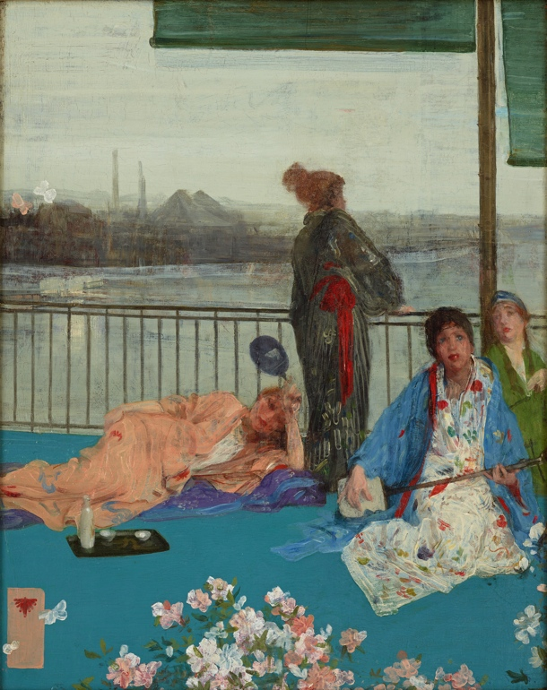
Name _______________________
On the left is James McNeill Whistler’s oil painting, Variations in Flesh Colour and Green: The Balcony, 1864-70.
Look carefully at a large image of this painting for a few minutes before answering the following questions.

Observe and Analyze
1. Write the corresponding letter on each of these objects in the painting:
A Balcony railing
B Thames River
C Cherry blossoms
D Industrial city landscape
E Horizon line
F Foggy London sky and atmosphere
H Japanese fan
G Kimono (long, wide-sleeved Japanese robe worn with an obi tied around the waist.)
I Shamisen (a Japanese three-stringed music instrument)
J Sake set (for serving a Japanese alcoholic beverage made from rice)
K Butterflies
L Artist’s chop mark similar to a Japanese seal

2. From his title, we know Whistler was experimenting with color. Locate different flesh tones in this painting. Where has Whistler repeated various shades of pink and flesh tones?
3. Which main lines tie the composition to the edge of the picture frame?
4. Describe the brush strokes on the kimonos and background landscape.
5. What part of this painting is most abstract, with the fewest recognizable details?
Interpret – 6. What happened in Japan that enabled Whistler and European artists to see Japanese art?

