Student Name___________________________________ Date_________

Write words and phrases describing each artwork in the circle for that painting. Write similarities for both paintings in the center overlapping area.

# Compare and Contrast

# James McNeill Whistler, *Upright Venice,* 1880, etching

# Andō Hiroshige, *View of Mogami River and Gassan mountain,* *Dewa* woodcut

**etchingby Whistler**

**woodblock print by Hiroshige**

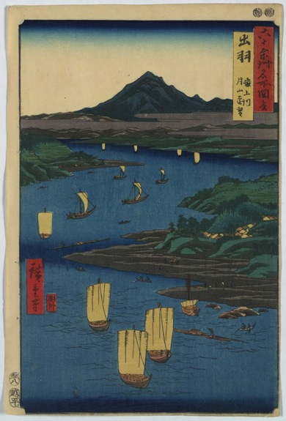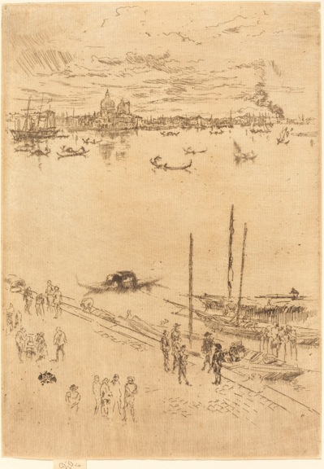

Andō Hiroshige, *View of Mogami River and Gassan Mountain, Dewa*, 1853, Woodcut, color, 35.8 x 24.1 cm, Prints and Photographs Division, Library of Congress

[Whistler, James McNeill](http://www.nga.gov/content/ngaweb/Collection/artist-info.1974.html), American, 1834 – 1903,

*Upright Venice,* 1880*,* Etching, 25.5 x 18 cm, National Gallery of Art, Washington, Rosenwald Collection