**Name_________________________________________**

**Where Will You Place the Horizon?**

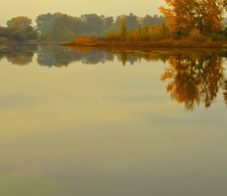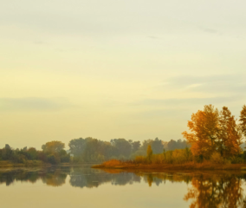

As Whistler composed his etchings and paintings, he experimented with balance and viewpoints. He often arranged space like that in Japanese prints, placing the horizon near the top of his compositions. As he did this, his art became more abstract.

Photograph or sketch the same landscape scene twice. In one view place the horizon low in the picture plane as in A. In the second view locate the horizon line high in the picture plane as in B.

Analyze and reflect on your compositions.

1. Describe how placing the horizon line in different parts of your sketch or photograph changed the appearance of space or depth in your art.

2. Which horizon placement seems less real or more abstract?

3. Which composition do you prefer? Explain why.

**A B**