Lesson 3: Whistler’s Drawing and Etching Techniques

“He is determined to make beauty out of the everyday. He saw what was before him but he then turns it into artistry.”
- David Park Curry, Senior Curator, Baltimore Museum of Art

“This was dirty dangerous, the biggest port in the world. It was a very dodgy place to live and work. Being an American he was outside society. It made him comfortable with lower class and upper class. He really looked as though he was settling there. The people there must have felt that he was one of them.”
- Margaret F. MacDonald, Art Historian, Glasgow University

Table of Contents

Introduction
Guiding Questions
Learning Objectives
Background for Teachers
Preparing to Teach This Lesson
Suggested Activities

[each of the following should be links to the activity within this lesson]

Activity 1. The Etching Process

Video: Heart, Eye & Hand – The Process of Etching

Essay: “Introduction to Etching”

Lesson 3.1 Etching Terms and Materials

Activity 2. Introduce, View, And Discuss Animated Sequence Of Whistler’s Etchings Featuring Entryways

Art Images: Animated Sequence of Whistler’s Etchings That Feature Entryways

Activity 3. Look and Think – The Lime-Burner and The Doorway

Art Image: Whistler, The Lime-Burner, 1859

Art Image: Whistler, The Doorway, 1879-80

Lesson 3.2 Closer Look at The Lime-Burner and The Doorway Worksheet
Lesson 3.3 Closer Look at The Lime-Burner and The Doorway Worksheet Answers

Activity 4 Studio. Draw an Entryway

Activity 5 Assessment and Reflection. Draw an Entryway
Lesson 3.4 Entryway Drawing Reflection
Lesson 3.5 Assessment of Student Drawing of Entryway and Reflection

Activity 6 Lesson Extension: Create an Etching

Handouts for Lesson 3
Other Resources
The Basics
Standards Alignment

Introduction In this lesson students will watch artist and printmaker Norman Ackroyd demonstrate etching in the short video Heart, Eye & Hand – The Process of Etching. Students will review the etching process using the Etching Terms and Materials worksheet. Then they will closely study Whistler’s drawing and composition in two etchings, The Lime-Burner and The Doorway. After observing how he drew lines to create dark and light values and how he often framed views within an entry. Students will draw an entry such as a gate or a door.

Guiding Questions
How are etchings created?
What types of lines did Whistler draw in his etchings?

Learning Objectives
At the end of this lesson students will be able to:
- Describe lines in Whistler’s etchings.
- Locate and identify hatching and crosshatching in Whistler prints.
- Discuss how Whistler framed views with entryways in his compositions.
- Explain the etching process.
- Draw an entryway and the view inside it.
- Include a variety of line types in a drawing.
- Create values with line.

Background for Teachers
The Lime-Burner
Whistler created this genre scene in 1859, while etching in a working class area near London’s busy, polluted Thames River. At this point in his career, he was a Realist following the advice of Gustave Courbet and Charles Baudelaire by painting and drawing what he saw and celebrating the dignity of everyday life. The Line-Burner was part of “The Thames Set.” More information about these prints is in “The Thames Set”. [http://www.odysseymedia.org/introduction-to-etching/the-thames-set/]

Whistler had studied art as a child in St. Petersburg, and at West Point. After his expulsion from West Point, Whistler worked for a short time as a mapmaker for the Division of Drawing and Engraving at the United States Coast and Geodetic Survey in Washington, DC, where he learned to etch.
He then moved to Paris to study painting and discovered that etching was enjoying a new found popularity among young artists. He realized he had a true talent for this medium and took it up with great success.

The Doorway
Whistler created this etching of a once-grand palace on a Venetian canal between 1879 and 1880. He had been commissioned by the Fine Art Society of London to create twelve etchings in four months, but he remained in Venice over a year creating over fifty etchings and pastels and paintings. By selling these etchings he hoped to recapture his art reputation and money for the legal expenses incurred in his libel suit against art critic John Ruskin. When he exhibited the etchings in London, they sold well. More information about Whistler’s Venice etchings is in “The Venice Sets.” [http://www.odysseymedia.org/introduction-to-etching/the-venice-sets/]

Learn more about Whistler’s life and career in “Talented Boy” and “The Artist.” [http://www.odysseymedia.org/art-life/talented-boy/] [http://www.odysseymedia.org/productions/whistler/about-the-artist/]

Preparing to Teach This Lesson
Review the lesson plan and the websites used throughout. Locate and bookmark suggested materials and websites. Download and print out documents you will use. Duplicate copies as necessary for student viewing.
Preview videos:
Heart, Eye & Hand – The Process of Etching [<link to this video Process of Etching]
and
animated sequence of Whistler’s etchings that feature entryways [Link to <Odyssey_WM_SH09_ThematicEtchings_Final_NEEDS NEW NARRATION.mov>]

Students may access materials at <http://www.whistlerthemovie.com>.

Handouts for Lesson 3:
[Link to each of the following within this lesson]
Lesson 3.1 Etching Terms and Materials
Lesson 3.2 Closer Look at The Lime-Burner and The Doorway Worksheet
Lesson 3.3 Closer Look at The Lime-Burner and The Doorway Worksheet
Lesson 3.4 Reflection on Entryway Drawing
Lesson 3.5 Assessment of Student Drawing of Entryway and Reflection

Suggested Activities
[Each of the following should be links to the activity within this lesson]

Activity 1. The Etching Process

Activity 2. Introduce, View, And Discuss Animated Sequence Of Whistler’s Etchings Featuring Entryways

Activity 3. Look and Think – The Lime-Burner and The Doorway

Activity 4 Studio. Draw an Entryway

Activity 5 Assessment and Reflection. Draw an Entryway

Introduction Explain to students that in this lesson they will learn how etchings are created before studying two of Whistler’s etchings, The Lime-Burner and The Doorway. They will look carefully at how he drew lines to create dark and light values in these prints. Then they will use some of these drawing techniques in their own drawings.

Activity 1. The Etching Process
In the 15-minute video, Heart, Eye & Hand – The Process of Etching [<link to this video Process of Etching] artist and printmaker Norman Ackroyd explains how an etching is made. Before viewing the video, tell students to look for the terms and materials listed on the Etching Terms and Materials worksheet. [Link to Lesson 3.1 Etching Terms and Materials] These are:
copper plate | ground | brayer or roller | flame | needle
mirror | acid | leather strips or muslin | paper | printing press.

After students view the video, review the etching process and how each of the materials on the worksheet is used. Have them illustrate the etching process on the Etching Terms and Materials worksheet. Students may refer to “Introduction to Etching.” [http://www.odysseymedia.org/introduction-to-etching/]

Activity 2. Introduce, View, And Discuss Animated Sequence Of Whistler’s Etchings Featuring Entryways

Show students a short animated sequence of Whistler’s etchings that feature entryways [Link to <Odyssey_WM_SH09_ThematicEtchings_Final_NEEDS NEW NARRATION.mov>]
Before viewing the animation sequence, tell students to notice the types of entryways and the views through these openings and thresholds. Often the entries frame the view seen through them. They should notice that some areas or subjects in each scene are more detailed and realistic than other parts of the scene.
After viewing the animation sequence, discuss what students noticed in the drawings. You may wish to show this animation again.
Activity 3. Look and Think – The Lime-Burner and The Doorway
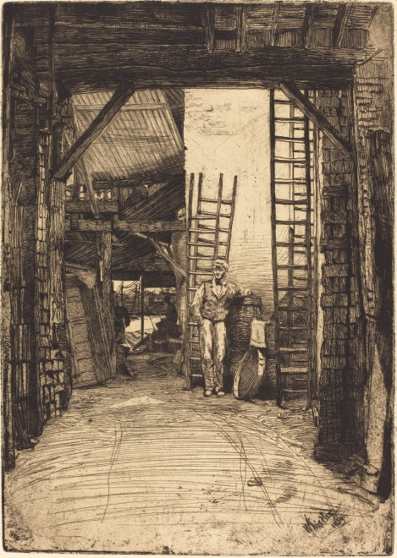
Look closely at the The Lime-Burner. [Link to The Lime - Burner_NGA.jpg]

As students view a large image of Whistler’s etching, The Lime-Burner, have them answer the questions on the Closer Look Worksheet, [Link to <Lesson 3.2 Closer Look “The Lime-Burner”>]. An answer sheet for these questions is included. [Link to Lesson 3.3 Answers “Closer Look, The Lime-Burner”] Use students’ answers in a class discussion of this etching. As they answer questions add information and encourage them to consider Whistler’s drawing techniques and composition. Zoom in and enlarge the image so that students can see even more details.
A James McNeill Whistler,
The Lime-Burner, 1859,
Etching, 25.5x18 cm. National Gallery of Art, Washington
Class Discussion:
Closer Look at The Lime-Burner and The Doorway
1. Imagine walking through the entryway in The Lime-Burner to the river in the background. What would you pass as you walked back to the distant river?
Ladders, sieve, standing man wearing cap and vest, barrels,
towel, boat, indistinct sitting man, wood and brick walls

Ask students to describe the standing man, the lime-burner. Note his 19^{th-}Century work clothes. He wears a workman’s cap and has smudges on his face and hand. Describe his pose. Does he seem tired? Maybe he is taking a break from his work. Lime burning was hard, hot labor. Dangerous gases were emitted as shells or limestone were burned to a powered lime used in construction mortar.

Describe the surface of the path you would walk on.
It seems smooth, perhaps hard packed dirt with wagon ruts and pebbles or litter along the edges.
What would you see if you looked up?
Dark wooden rafters are in the foreground. Because light shines on the lime burner, this may be a courtyard open to the sky. Behind the standing man is a wooden beam and a variety of wooden ceilings beyond this.

2. Write a word or phrase describing the building in A.
Terms such as ramshackle, industrial, disorderly, junky, dirty, multilevel
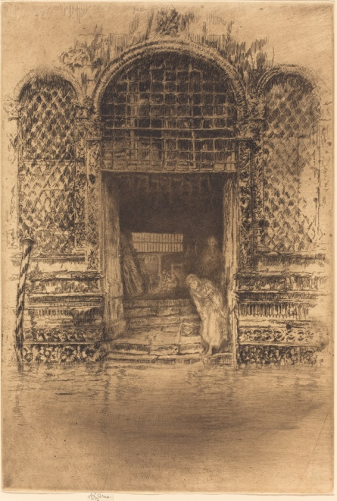
3. Write a word or phrase describing the building in B.
Terms such as arches, once grand Venetian house on canal, tiles, ornate, dark interior Steps suggest that it is need of repair.

4. In which print is the viewer closer to the entry? A

Notice that water comes to the lower steps of the doorway in B. This house is on a canal in Venice.

5. In which print is the main person drawn in most detail? A
B James McNeill Whistler, The Doorway, 1870-80, Etching, 29.5x20 cm. National Gallery of Art,Washington

6. Compare the vertical sides of each print.
Which are darker? A
Drawn in most detail? A

7. What was Whistler most interested in showing in A?
Standing man and interior of the building, real ordinary life scene

8. What was Whistler most interested in showing in B?
Exterior of the building, an exotic (to London) scene in a beautiful piece of art. However, the interior is centered with a dark suggestion of a courtyard and people.

Call attention to the patterns in B. Challenge students to identify at least 3 different patterns. There are more in addition to the squares over the central entry, the diamond shapes on each side, and the floral borders at the base of the building.

Ask students to compare the thickness of most of the lines in The Lime-Burner to those in The Dooway. The lines in The Doorway are much finer.

Analysis of The Lime-Burner
Ask: How has Whistler indicated depth in The Lime-Burner?
Objects overlap. Distant objects are smaller, less distinct, and higher in the picture plane.

Ask: How does Whistler lead our gaze into and through this composition?
We follow the path from the lower edge of the etching back to the distant river. Wagon ruts in the path help direct the eye movement to the back.

Ask: What part of The Line-Burner seems most important? How has Whistler emphasized this part?
The lime-burner and the distant scene behind him create a focal point near the center of the composition. The path with rut lines leads to it. The distant man sitting in shade contrasts with the white wall and very detailed standing man.

Point out the different types of lines Whistler made as he drew The Lime-Burner. Ask students to find
- areas of closely spaced parallel lines that gradually come close together creating darker values. This technique is called hatching.
- areas of cross-hatching where values become even darker.
- different angles of the lines in roof area to the upper left of the standing man.
- various textures in this etching. Note the textures of the bricks, wood beams, sieve, and light plaster wall behind man.

Whister’s signature and date, 1859, is in the lower right corner of The Lime-Burner. When Whistler created this in London, he was 25 years old, early in his career. At this point he was a Realist, accurately drawing the scenes surrounding him. By 1880 when he created The Doorway, he had embraced the idea of “art for art’s sake.”

Ask: Who might buy The Lime-Burner? The Doorway? What would the buyer appreciate about these prints?
There was a growing middle class in London who could afford to buy art. Prints were usually more affordable than paintings. Patrons might purchase these prints because they thought they were beautiful, or they appreciated Whistler’s drawing and compositional skill. Or they might enjoy owning a scene that was familiar to them as in The Lime-Burner. They, like Whistler, might realize that London was changing and soon would look differently. Travelers who had visited Venice might enjoy The Doorway as a momento of their vacation.

Activity 4 Studio. Draw an Entryway

In this activity students draw an entryway and what is seen inside or through it.

Depending on the drawing expertise of your students, they may begin by experimenting with various line types before attempting a larger sketch. Point out different kinds of lines in Whistler’s etchings. Using markers, pen and ink, or pencils students may use hatching, a series of short closely spaced parallel lines to create values ranging from light to dark. They may add cross-hatching (a series of lines drawn across the hatch marks.) Suggest that students draw a simple object with quick, almost scribbly lines like Whistler sometimes drew.

Assign students to draw a familiar entry such as the main door to the school or gym, a gate to a park, their bedroom door or an opening in a building or fence. As they compose and plan their drawing, they should consider what will be the most important part of their picture and how they will emphasize it. Will they center this entry on their page? Will they use value contrasts to direct attention to it? Maybe they will draw lines leading towards it. Tell students to use hatching and cross-hatching to create a range of values in their drawing. They should look at the entry as they sketch with pencil or markers.

What’s inside? Students might draw the actual view inside the entry, or they might use their imaginations to draw what they wish were there. Alternatively they might paste a photograph or montage of photographs inside the door.

Activity 5 Assessment and Reflection. Entryway
Have students write a title and a short description of their sketch of an entryway. They may use the Reflection on Entryway Worksheet [<Link to Lesson 3.4 Entryway Drawing Reflection>].
See the Assessment Rubric for students’ drawings and reflections. [Link to Lesson 3.5 Assessment of Student Drawing of Entryway and Reflection]
Activity 6 Lesson Extension. Create an Etching
• Create an Etching
Have students create etchings from their entryway sketches made in this lesson.

• Draw on scratchboard.
Although not a printing process, students may experience drawing with a needle by scratching lines on scratchboard. Prepared scatchboard may be purchased from art supply stores, or make scratchboard by painting a layer of black India ink over clay-coated poster board.

Other Resources
EDSITEment Lesson Plans
Composition and Content in the Visual Arts
http://edsitement.neh.gov/lesson-plan/composition-and-content-visual-arts

Composition in Painting: Everything in its right place (4 Lessons)
http://edsitement.neh.gov/curriculum-unit/composition-painting-everything-its-right-place

The Basics
Grade levels – 6-8 or 9-12
Subject areas
Art and Culture: Visual Arts, Art History
Literature and Language Arts: Common Core
Time required 3 or 4 periods

Standards Alignment National Core Arts Standards: National Visual Arts Standards <http://nationalartsstandards.org>
Grade 6
VA:Re7.2.6
Analyze ways that visual components and cultural associations suggested by images influence ideas, emotions, and actions.

Grade 8
VA:Re8.1.8
Interpret art by analyzing how the interaction of subject matter, characteristics of form and structure, use of media, art-making approaches, and relevant contextual information contributes to understanding messages or ideas and mood conveyed.
VA:Re8.1.HSI
Interpret an artwork or collection of works, supported by relevant and sufficient evidence found in the work and its various contexts.
Grade 7
VA:Cr2.3.7
Apply visual organizational strategies to design and produce a work of art, design, or media that clearly communicates information or ideas.

Grade 7
VA:Cr3.1.7
Reflect on and explain important information about personal artwork in an artist statement or another format.

Common Core State Standards Initiative – English Language Arts Standards <http://www.corestandards.org/ELA-Literacy/>
CCSS.ELA-LITERACY.W.9-10.2.D
Use precise language and domain-specific vocabulary to manage the complexity of the topic.

CCSS.ELA-LITERACY.RI.11-12.7
Integrate and evaluate multiple sources of information presented in different media or formats (e.g., visually, quantitatively) as well as in words in order to address a question or solve a problem.
Author’s name and affiliation
Kaye Passmore, Ed.D
Art education consultant
Corpus Christi, Texas

Abstract: In this lesson students watch a short video of artist and printmaker Norman Ackroyd demonstrating etching. Students review the etching process and illustrate steps in the process on the Etching Terms and Materials worksheet. They study Whistler’s drawing technique and composition in two of his etchings, The Lime-Burner and The Doorway. After observing how he created dark and light values with lines and how he often framed views with entries, students draw an entryway and the view seen through it. They write a reflection on their drawing. An assessment rubric for the drawing and reflection is included.

