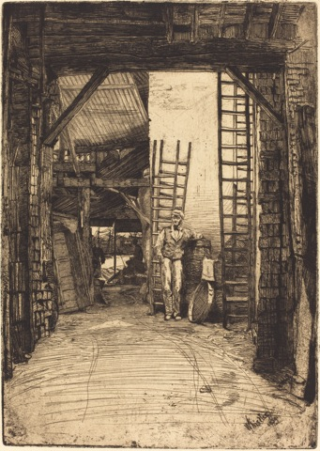
Name______________________
Closer Look at The Lime-Burner and The Doorway
1. Imagine walking through the entry in The Lime-Burner to the river in the background. What would you pass as you walked back to the distant river?

Describe the surface of the path you would walk on.
What would you see if you looked up?
2. Write a word or phrase describing the building in A.__________________
3. Write a word or phrase describing the building in B.__________________
A
4. In which print is the viewer closer to the entry? ________
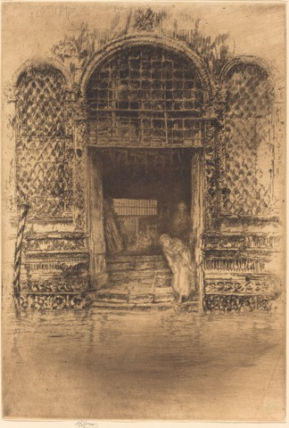
5. In which print is the main person drawn in most detail?______
6. Compare the vertical sides of each print.
Which is darker? ___
Drawn in most detail?______
7. What was Whistler most interested in showing in A?

8. What was Whistler most interested in showing in B?

A James McNeill Whistler, The Lime-Burner, 1859
Etching, National Gallery of Art, Washington

B James McNeill Whistler, The Doorway, 1879/80, Etching, National Gallery of Art, Washington
B

