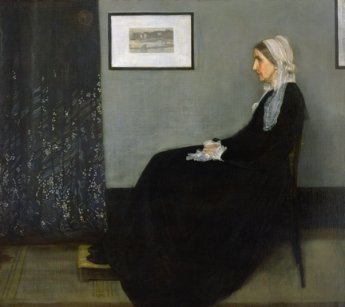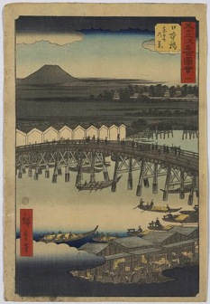

Andō Hiroshige, *Nihonbashi,* 1855, woodcut, color ; 36.4 x 24.9 cm. Library of Congress

"Art should be independent of all clap-trap—should…appeal to the artistic sense of eye or ear, without confounding this with emotions entirely foreign to it…Take the picture of my mother…as an *Arrangement in Grey and Black*. Now that is what it is…what can or ought the public care about the identity of the portrait?”  —*J. M. Whistler*

“Look how the Japanese understand this! the same colour reappearing continually here and there like the same thread in an embroidery … the whole forming in this way an harmonious pattern “ *J. M. Whistler*

James McNeill Whistler, *Arrangement in Grey and Black No.1, Portrait of the Artist's Mother*, 1871 (oil on canvas) 144.3x162.5 cm. Musée d'Orsay, Paris, France

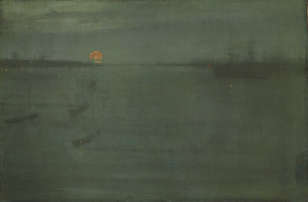

“As the light fades and the shadows deepen, all petty and exacting details vanish, everything trivial disappears, and I see things as they are in great strong masses … And *that*, night cannot efface from the painter's imagination.”

*J. M. Whistler to a sitter who asked how it was possible to paint when it was so dark*

James McNeill Whistler, *Nocturne: Blue and Gold--Southampton Water*, 1872, Oil on canvas, 50.5 x 76 cm. Art Institute of Chicago