Name___________________________________

Write words and phrases describing each artwork in the circle for that painting. Write similarities for 2 paintings in their overlapping areas and similarities for all 3 in the center.

# Compare and Contrast

# A. Andō Hiroshige, *Nihonbashi,* woodcut, 1855

# B. James McNeill Whistler, *Arrangement in Grey and Black No.1, Portrait of the Artist's Mother*, oil on canvas, 1871

# C. James McNeill Whistler, *Nocturne: Blue and Gold--Southampton Water*, oil on canvas, 1872

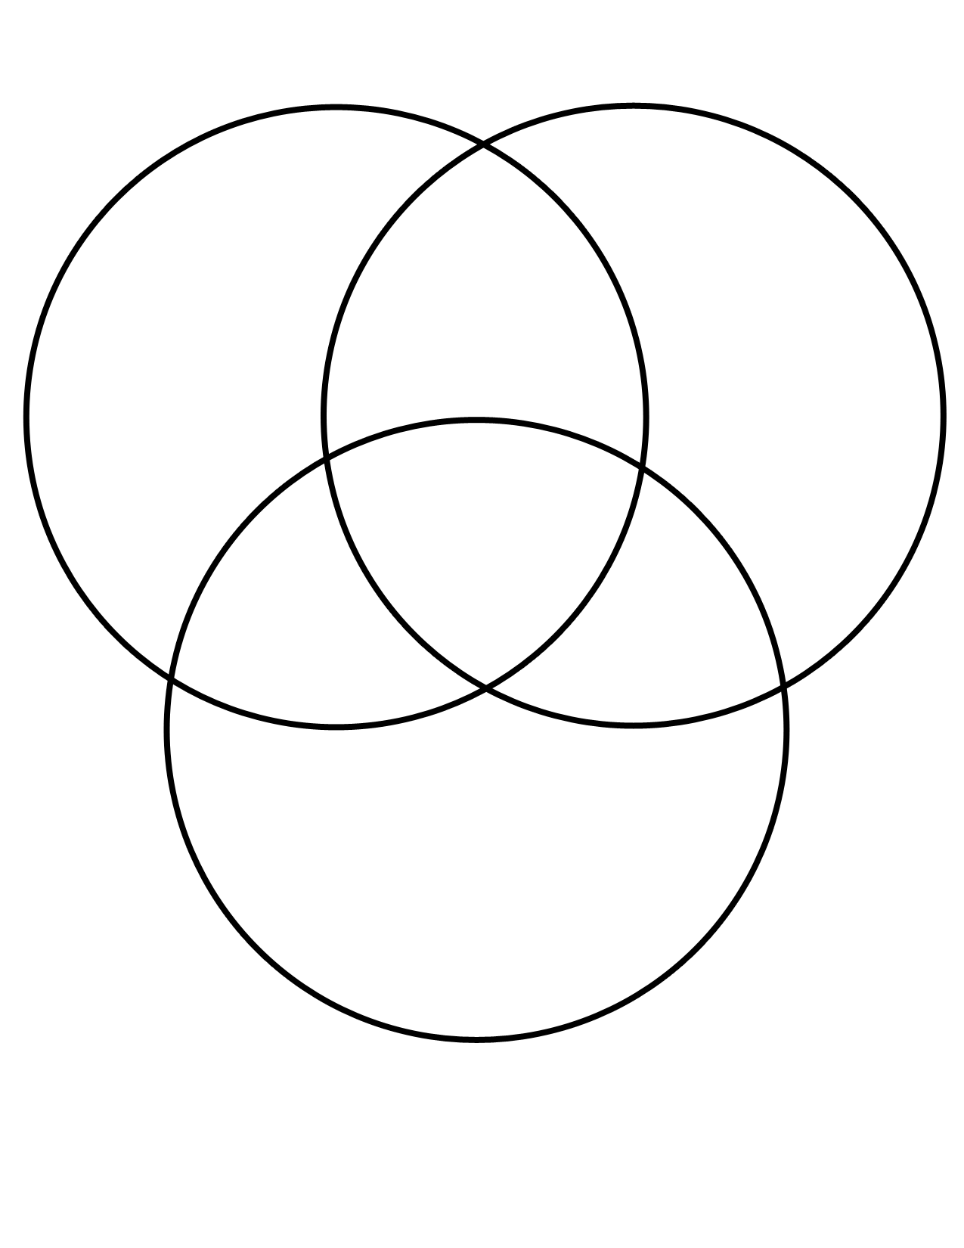

Whistler, *Arrangement in Grey and Black No.1, Portrait of the Artist's Mother*

A. Hiroshige, *Nihonbashi*

Whistler, *Nocturne: Blue and Gold – Southampton Water*